Unicom TIC Management System
C# Project Report
UNICOM_TIC/2025/A/UT010615

Introduction
Acknowledgment
Table of Contents
Introduction 2
Problem Definition 3
Customer Requirements 4
Feasibility Study……………………………………………………………………………….5
Design……………………………………………………………………………….................6
Coding / Development………………………………………………………………………....7
Testing………………………………………………………………………………..............10
Work Breakdown Structure………………………………………………………………......12
References 13

Problem Definition
The current Unicom TIC Management System faces several critical issues affecting its usability and functionality:
- Login Functionality Issues:
Users experience difficulties during the login process, including failed authentications and improper handling of user roles. This hinders users from accessing their respective dashboards and functionalities smoothly.

- Marks Visibility Problem:
Students are unable to view their marks within the system. This lack of access to academic performance data reduces transparency and creates confusion for students seeking to track their progress.

- User Details Accessibility:
Users such as students, lecturers, and staff cannot access or view their personal details after login. This limits the system's effectiveness as a comprehensive management tool and impacts user satisfaction.

- General Usability Concerns:
The system’s interface and responsiveness need improvements to ensure user-friendliness and a seamless experience across various user roles.

Customer Requirements

1. Functional Requirements
- Login:
Users must securely log in to their personal accounts.
- User Roles:
Different user types (Admin, Lecturer, Staff, Student) should be able to log in separately.
- Registration:
New users should be able to register their details and create an account.
- Marks Viewing:
Students should be able to easily view their marks.
- View User Details:
Each user should be able to view and update their personal details.

2. Non-Functional Requirements
- Speed:
The application should operate quickly and information should be retrieved without delay.
- Responsive UI:
The system should have a uniform and easy-to-use interface across both desktop and mobile devices.
- Security:
User information and data must be securely protected.
- User Friendly:
The system should be easy to use for all types of users, from students to administrators.

Feasibility Study
- Technical Feasibility
Software:
- Server Operating System
- Security measures
- User Interface design
Hardware:
- RAM (Memory)
- Storage capacity
- Network Bandwidth
- Economical Feasibility
The project budget has been planned to ensure cost-effectiveness without compromising quality.
- Legal Feasibility
Compliance with relevant local laws and regulations, including .lk domain registration and data privacy.
- Operational Feasibility
User training will be provided through detailed user manuals to ensure smooth operation.

Design
- Diagrams
  - Entity-Relationship (ER) Diagram: Represents the database structure showing tables and relationships.
  - Use Case Diagram: Illustrates the interactions between users (Admin, Lecturer, Staff, Student) and the system functionalities.
  - Activity Diagram: Describes the workflow of key processes like login, registration, and marks management.
- Wireframes
  - Login Page: User inputs for username, password, role selection, and ID.
  - Registration Page: Fields for user details, password setup, and role selection.
  - Dashboard Pages: Separate panels for Admin, Lecturer, Staff, and Student with navigation menus.
  - Marks Management: Interfaces for adding, viewing, updating, and deleting marks.
  - Timetable, Exam, Course, and Subject Management screens designed for ease of use.
- Architecture
  - The system follows the MVC (Model-View-Controller) architectural pattern to separate business logic, user interface, and data handling.
  - Object-Oriented Programming concepts like inheritance and polymorphism are used to manage different user roles efficiently.
- User Interface Design
  - Focus on responsive, user-friendly design compatible across devices.
  - Consistent theme and navigation for seamless user experience.

Coding / Development
The development of the Unicom TIC Management System was carried out using C# with Windows Forms for the user interface and SQLite as the database backend. The system was designed following the Model-View-Controller (MVC) pattern to maintain separation of concerns and improve maintainability.

Key Features Implemented:
- User Authentication: Secure login system supporting multiple user roles such as Admin, Lecturer, Staff, and Student.
- Role-Based Access Control: Each user type has access only to the functionalities relevant to their role.
- CRUD Operations: Create, Read, Update, Delete functionalities are implemented for managing Admins, Lecturers, Staff, Students, Courses, Subjects, Exams, Marks, Timetables, Rooms, and Attendance.
- Marks Management: Students can view their marks; Admins and Lecturers can add, update, and delete marks.
- User Details Management: Users can view and update their personal details after login.
- Dynamic UI Loading: Using a TreeView control, the system loads relevant forms dynamically based on user selection.

Programming Techniques:
- Object-Oriented Programming (OOP): Used inheritance and polymorphism to handle different user roles efficiently.
- Database Connectivity: Used SQLiteConnection and SQLiteCommand classes to interact with the SQLite database.
- Error Handling: Implemented try-catch blocks to manage exceptions and provide feedback to the user.
- Event-Driven Programming: UI controls use event handlers to trigger actions such as button clicks and tree node selections.

Sample Code Snippet
- Marks Management Controller
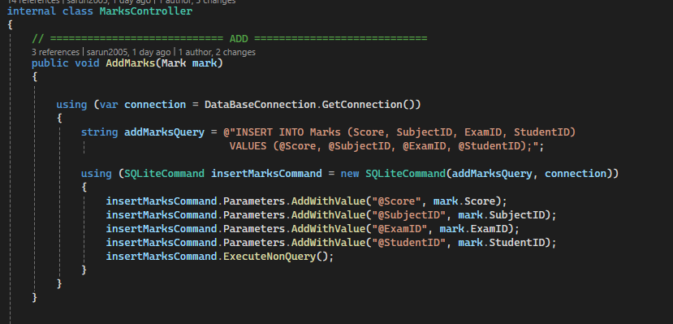

- Marks Management Controller
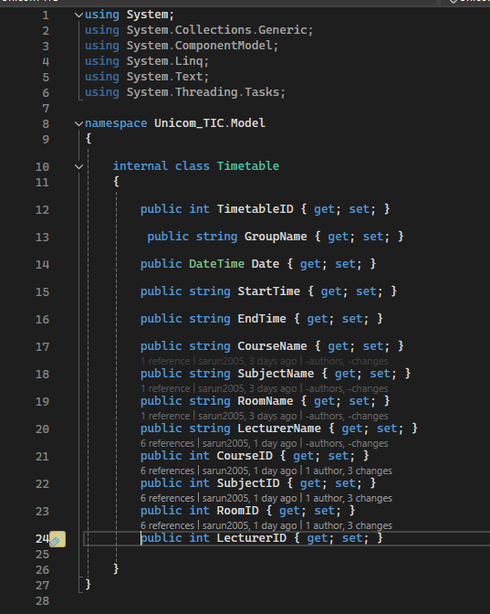

Testing
The testing phase for the Unicom TIC Management System was carried out to ensure the software functions correctly and meets the specified requirements. Different testing strategies were used to identify and fix bugs, improve reliability, and verify that the system performs as expected.
Types of Testing Conducted:
- Unit Testing:
Individual modules such as login, registration, marks management, and user profile updates were tested in isolation to verify that each function works correctly.
- Integration Testing:
Tested the interaction between different modules, such as how the login system connects with user role validation and dashboard navigation.
- System Testing:
The complete system was tested as a whole to ensure all features work seamlessly together.
- User Acceptance Testing (UAT):
Selected users from different roles (Admin, Lecturer, Staff, Student) tested the system to ensure it meets real-world usage requirements.

Test Case ID | Description | Input | Expected Output | Actual Output | Result | Tester Name | Test Date
TS01 | Login with empty username | Username: "" Password: "123" | Error message: "Username required" | Matches | Pass | Tester1 | 2025-06-22
TS02 | Student views marks | Student ID: 1 | List of marks displayed | Matches | Pass | Tester2 | 2025-06-22
TS03 | Update admin details | New email: "admin@example.com" | Details updated successfully | Matches | Pass | Tester3 | 2025-06-23

Bug Fixes and Improvements:
- Fixed login failures due to incorrect role handling.
- Resolved marks visibility issues for students.
- Enhanced UI responsiveness and user experience based on feedback.
- Secured data handling to prevent unauthorized access.

Work breakdown Structure

No | Task | Start Date | End Date | Duration (Days)
01 | Requirement Gathering | 05-06-2025 | 7-06-2025 | 2
02 | Design | 08-06-2025 | 10-06-2025 | 2
03 | Development | 11-06-2025 | 20-06-2025 | 9
04 | Testing | 21-06-2025 | 23-06-2025 | 2
05 | Documentation | 23-06-2025 | 24-06-2025 | 5

Explanation:
- Task: The phase or activity.
- Start Date: When the task starts.
- End Date: When the task finishes.
- Duration: Total number of days taken.

References
- https://learn.microsoft.com/en-us/dotnet/csharp/
- https://www.w3schools.com/cs/
- https://sqlite.org/docs.html

